Artificial Airways

Upper airway obstruction may occur from two sources: soft tissue obstruction (most common) and laryngeal obstruction.

- Oropharyngeal Airway:

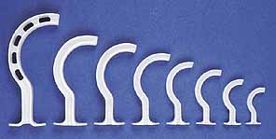

Inserted into the mouth between the lip and teeth. It extends from the lips to the pharynx. It follows the natural curve of the tongue. They are made of plastic and are rigid. It consist of a flange, body and air channel. Oropharyngeal airway is designed to prevent the patients tongue from falling backward and obstructing he hypopharynx. Indications: spontaneous, manual, or mouth to tube ventilation. Also, may be used as a bite block for patients that are orally intubated. In semicomatose or alert patients, Oropharyngeal airway may gag or induce vomiting and increase the risk of aspiration. Other complication may be laryngospasm, coughing, and dental damage.

To insert an oropharyngeal airway using the cross-finger technique to open the patients mouth. One method of insertion is to turn the airway 180 degrees from its resting position as it is passed over the tongue to avoid pushing the tongue back into the pharynx. When the tip of the airway reaches the uvula, the airway is rotated 180 degrees so that the tip is positioned behind the tongue and facing the larynx. Another method is inserting the oral airway utilizing a tongue depressor this allows you to directly visualize the placement.

- Nasopharyngeal Airway:

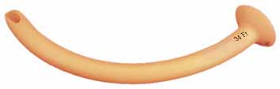

Nasopharyngeal is an alternative to oropharyngeal airway. It is inserted into the nose and directed along the floor of the nasal passage parallel to the hard palate. They are made of soft plastic or rubber. To select the proper length of the nasopharyngeal airway, measure the distance from the tip of the nose to the meatus of the ear.

Better tolerated in semi-awake patient than oral airways. It eliminates the risk of trauma to the tongue and teeth. Used in bronchoscopy and nasotracheal suctioning (trauma).

When inserting a nasopharyngeal airway, first lubricate it with a water-soluble gel. It is than introduced into one of the nairs, and advance gently to prevent trauma and bleeding. If resistance is met, try the other nair.

Complications of nasopharyngeal airways: laryngospasm and coughing if too long.; nosebleeds; damage turbinate; sinus infection (prolong use).
Severe facial trauma - Contraindication.

Oxygen Devices:

Goals of increasing fraction of inspired oxygen (FIO₂) therapy
- Oxygen is delivered form taps above ward beds at 100% concentration. (0.5 –
15L per minute.
2. Increase oxygen tension in alveolus/alveoli.
3. Possibly decrease the ventilatory work necessary to maintain alveolar oxygen.
4. Maintain arterial oxygen tension to possibly decrease myocardial work.
5. The percentage of oxygen inspired depends on the flow rate and the delivery
device.

Types of Oxygen Devices:

I. Low-Flow – deliver oxygen at flow rates usually no greater than 6 L/min, insufficient to meet patients inspiratory flow demands of 30 L/minute. The remaining inspired air is supplied by room air.

Nasal Cannula – most widely used to administer low-flow oxygen to adults, children and infants. Well tolerated with flow rates up to 6 L/min. Deliver FIO₂ of 24% at 1L/min and up to about 40% at 5-6L/min. For easy calculation of percent FIO₂ for nasal cannula, multiply the liter flow by 4 and add it to 21 = an approximate FIO₂ (%) L/min x 4) + 21 = 29 %). Used in non-acute situations or if only mildly hypoxic.

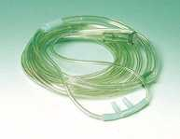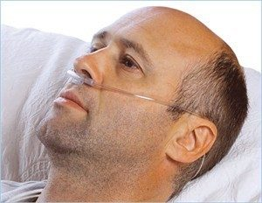

Non-rebreather Mask – If this system was perfect, it would deliver 100% oxygen. However, at flows of 10 to 15 L/min, only FIO₂ of 85 – 90% are achieved. Used for acutely ill patients. Note that saturations should be maintained at 94-98%, not 100%.

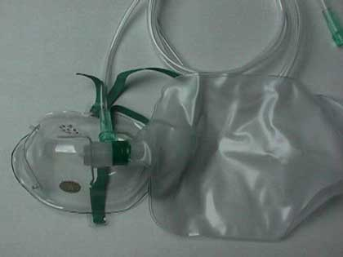

II. High-Flow – Meet the patient’s full inspiratory flow demand and thus maintain a fixed FIO₂. These devices are unaffected by change in respiratory pattern or rate.

Venturi Mask – uses Bernoulli principle; entrains room air in static proportion to oxygen flow. These devices provide high to total gas flows of fixed FIO₂. Venturi mask will provide concentrations of FIO₂ between 24-60%. Used often for COPD, where it’s important not to over-oxygenate the patient.

Blue = 2-4L/min = 24% O₂
White = 4-6L/min = 28% O₂
Yellow = 8-10L/min = 35% O₂
Red = 10-12L/min = 40% O₂
Green = 12-15l/min = 60% O₂
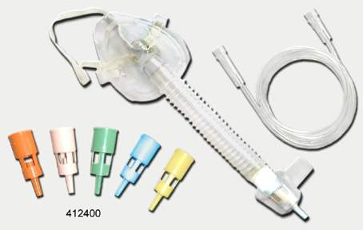

III. Non-Invasive Ventilation (CPAP / BiPAP):

CPAP (Continuous Positive Airway Pressure)
    - High pressure air/oxygen with a tight-fitting mask
    - Positive pressure all the time to help keep airways open (split them)
    - Used in acute pulmonary edema and sleep apnea.

BiPAP (Bilevel Positive Airway Pressure)
  - High positive pressure on inspiration and lower positive pressure on expiration
  - Used in exacerbation of COPD and ARDS.

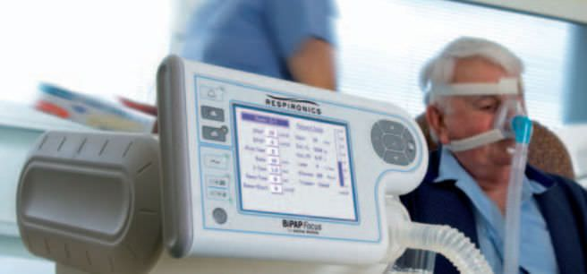

IV. Invasive Ventilation

Mechanical Ventilation – artificial airway to ventilate lungs.
Oxygen delivery up to 100%
Used in critical ill patients.

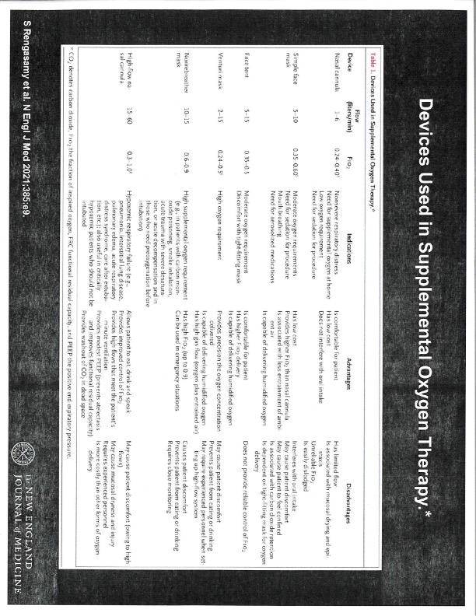

References:

- Hess, Neil etc. (2002). Respiratory Care: Principles and Practice.
- Shapiro (1979). Clinical Application of Respiratory Care.
- S Rengasamy et al. N Engl J Med 2021;385:e9.

